**Computer Programming and Video Game Design (2 Years)**

|  |  |
| --- | --- |
| **INSTRUCTOR** | |
| ***Finger Lakes Technical and Career Center*** |
| Keith A. Calaman keith.calaman@wflboces.org 585-526-6409 |

**Program Goal:**Computer Programming and Video Game Design enables students to learn web design, software development, game programming, computer and network support. Students may earn up to 15 transferrable college credits from Finger Lakes Community College. Students will learn several different programming languages and paradigms through the creation of web sites, games, and computer applications. Students will obtain industry certifications through on-line tools and certification exams provided by  and https://www.youscience.com/wp-content/uploads/2020/08/Precision-Exams-Sub-YS-Logo.png. The course will be taught utilizing a blended learning model with an in-person instructor and the Moodle Virtual Learning Environment (VLE) on the World Wide Web. Students will be expected to follow provided acceptable use policies.

**Curriculum:**During the first year of this program, students learn the essentials of computer programming and practice their skills through programming exercises and by writing their own computer programs. Students are taught concepts from geometry, trigonometry, and algebra necessary to model real world physics in games and simulations.

**Video Game Programming**: Students study the Windows programming model using .NET and C#. C# is the most modern programming language desired by professional software development firms. Students apply their skills to collaborate on a substantial game development project using C#, Visual Studio, Unity game engine and/or other tools.

**Computer Networking and PC Support:** Students study the fundamentals of computer and networking technology as well as desktop and server operating systems. Students will also design, implement and support networks and PCs in a lab environment. In addition to the TestOut certifications the curriculum also includes preparation for the CompTIA A+ and Network+ exams if the student chooses.

**Practicum & Work Based Learning:** Students will collaborate to form one or more brand identities under which we will attempt to market our computer programs.

**Curriculum Areas/Units of Study:**

1. COMPUTER PROGRAMMING AND SYSTEMS DESIGN

Basic Elements of All Programming Languages:

1. Formal logic statement blocks: things between {}.
2. Variables, constants & data types.
3. Functions & methods.
4. Operators & Expressions.
5. String manipulation.
6. Lists & arrays.
7. Looping & repeating instructions.
8. File & Directory management.
9. SQL & data driven applications.
10. Maintaining state.
11. Error handling, testing, debugging.
12. Efficiency.
13. Security.

Systems Design & Programming Strategies:

1. Planning & documentation.
2. The Systems Development Life-Cycle.
3. Self-care & mindfulness.
4. Object Oriented vs. Procedural languages
5. Algorithms.

Languages Used:

1. **HTML/CSS:** The foundation of web driven documents. We will place HTML documents on a web server and build a CSS template driven web application.
2. **JavaScript:** a client side language used commonly to validate input and manipulate custom controls in a web browser.
3. **PHP:** The language used on the most websites in the world. The web server we will be using is hosted in a Linux environment. Linux is a robust yet efficient open source operating system.
4. **C#:** The main object oriented language we will study. This is Windows based. We will study how to program in this language and build windows applications that are targeted to run within the windows operating system. It also is the language used to program in Unity.
5. **Java:** We will discuss Java and look at examples that demonstrate how Java differs both environmentally and programmatically to C#.
6. **SQL:** There are two components to SQL the DDL and DML. With the DDL you define how the database and objects in the database are structured. The DML is used to manipulate the data in the database. We will use these languages and learn basic relational database management concepts.

Integrated Development Environments

1. **Notepad++:** This is a basic text editor that has ftp capabilities we will use to work with files on our web server.
2. **Visual Studio:** Microsoft Windows implementation of an IDE we will use to perform several different tasks and objectives.
3. **Eclipse:** Open source IDE used to create Java Applications and work with Node.JS.

**GEMINI**

**Dual Credit (3 Credits Each):** Finger Lakes Community College

These courses are designed in conjunction with FLCC. You will be credited with the associated credit hours on your FLCC transcript. You can achieve a maximum of 15 college credit hours in this program throughout the two years. All of the work is integrated – meaning you will be working together as a class. However, it is expected that you perform well on assessments in items related to the Gemini course. A good example is the hardware course. You will earn an A if you gain the TestOut certification.

I don’t expect you to even register for the course if getting certified is not your goal. Hence, I expect the entire class to get an A. Same thing with the Web Site Development credits. If you don’t complete the mid-term properly and just demonstrate small pieces and parts of web pages on other assignments with some inline styles but never properly use a linked stylesheet you aren’t going to get any credit for the course because you did enough to pass through the program.

Gemini Progression and graded items:

|  |  |  |
| --- | --- | --- |
| **COURSE** | **WHEN** | **ASSESSMENT** |
| CSC 162 | Fall, Junior | Junior Mid-Term Project: Web Site |
| CSC 164 | Spring, Junior | Junior Project: Arcade/Web Site |
| CSC 115 | Fall, Senior | Senior Mid-Term: Precision Exam Programming I |
| CSC 271 | Spring, Junior | TestOut PC PRO Certification Exam |
| CSC 260 | Spring, Senior | TestOut Network Pro Certification Exam |

CSC 162 Web Site Development for New Media (3-0) 3 credits

This course is an introduction to Web site development. Students will learn how to design and develop Web pages using current technologies and tools. Topics covered will include the World Wide Web, HTML, Cascading Style Sheets (CSS), current browsers, and Adobe’s Web site creation and management application, Dreamweaver. Other topics include Web publishing, Web standards, and intellectual property law.  [View Course Syllabus [Adobe Acrobat, PDF](https://flcc.edu/pdf/syllabi/CSC162.pdf)](https://flcc.edu/pdf/syllabi/CSC162.pdf)

CSC 164 Introduction to Scripting for New Media (3-0) 3 credits

Introduction to scripting for New Media serves as a beginning level programming course for AS New Media students. This course emphasizes problem solving by way of the development and implementation of scripts in a web based environment. Writing code and using external scripting libraries in a structured object oriented scripting language will be covered. A contemporary scripting language is used throughout the course. Prerequisite: CSC 162.  [View Course Syllabus [Adobe Acrobat, PDF](https://flcc.edu/pdf/syllabi/CSC164.pdf)](https://flcc.edu/pdf/syllabi/CSC164.pdf)

CSC 115 CS1: Introduction to Programming and Computational Thinking (3-1) 3 credits

CS1: Introduction to Programming and Computational Thinking serves as a first course for all computer-related majors. This course is for beginning programmers, and is the first course in a sequence of three programming courses. The course emphasizes the development of languages and software, problem-solving, and programming in a structured, object-oriented language. The C# programming language is used throughout the course. Prerequisite: Success in relevant Algebra and Geometry course.  [View Course Syllabus [Adobe Acrobat, PDF](https://flcc.edu/pdf/syllabi/CSC115.pdf)](https://flcc.edu/pdf/syllabi/CSC115.pdf)

CSC 271 Hardware and Operating Systems (3-0) 3 credits

Hardware and Operating Systems is a course designed to prepare students to successfully earn CompTIA’s A+ certification. This course requires students to assemble, repair, configure and optimize modern computer systems. Students will be given a broad overview of computer systems, problems and solutions. Emphasis will be made to allow students to experience actual challenges with a computer, and design their solution.  [View Course Syllabus [Adobe Acrobat, PDF](https://flcc.edu/pdf/syllabi/CSC271.pdf)](https://flcc.edu/pdf/syllabi/CSC271.pdf)

### CSC 260 Networking Technologies (3-0) 3 credits

This course is the perquisite and absolute foundation for all upper level networking and cybersecurity courses, and features extensive hands-on activities. Topics include the OSI Model, MAC addresses, IP addresses, local communication vs. remote communication, packet sniffing, the TCP/IP protocol suite including ARP, ICMP, TCP, UDP, DNS, DHCP, IGMP, IMAP, SMTP, SSH and more, subnetting, switches, routers, cables virtualization, Ethernet, wireless, cybersecurity, and more. Various tools and utilities will be used throughout the course. Co-requisite: CSC 103  [View Course Syllabus [Adobe Acrobat, PDF](https://flcc.edu/pdf/syllabi/CSC260.pdf)](https://flcc.edu/pdf/syllabi/CSC260.pdf)

**Articulation Agreements:** SUNY Canton-September 2013-August 31, 2018 for Computer Technologies Program, Bryant and Stratton College-December 2012

**Mode of Delivery**

This course will be taught utilizing a blended learning model with the Moodle Virtual Learning Environment (VLE) on the World Wide Web. Students will be expected to follow provided acceptable use policies.

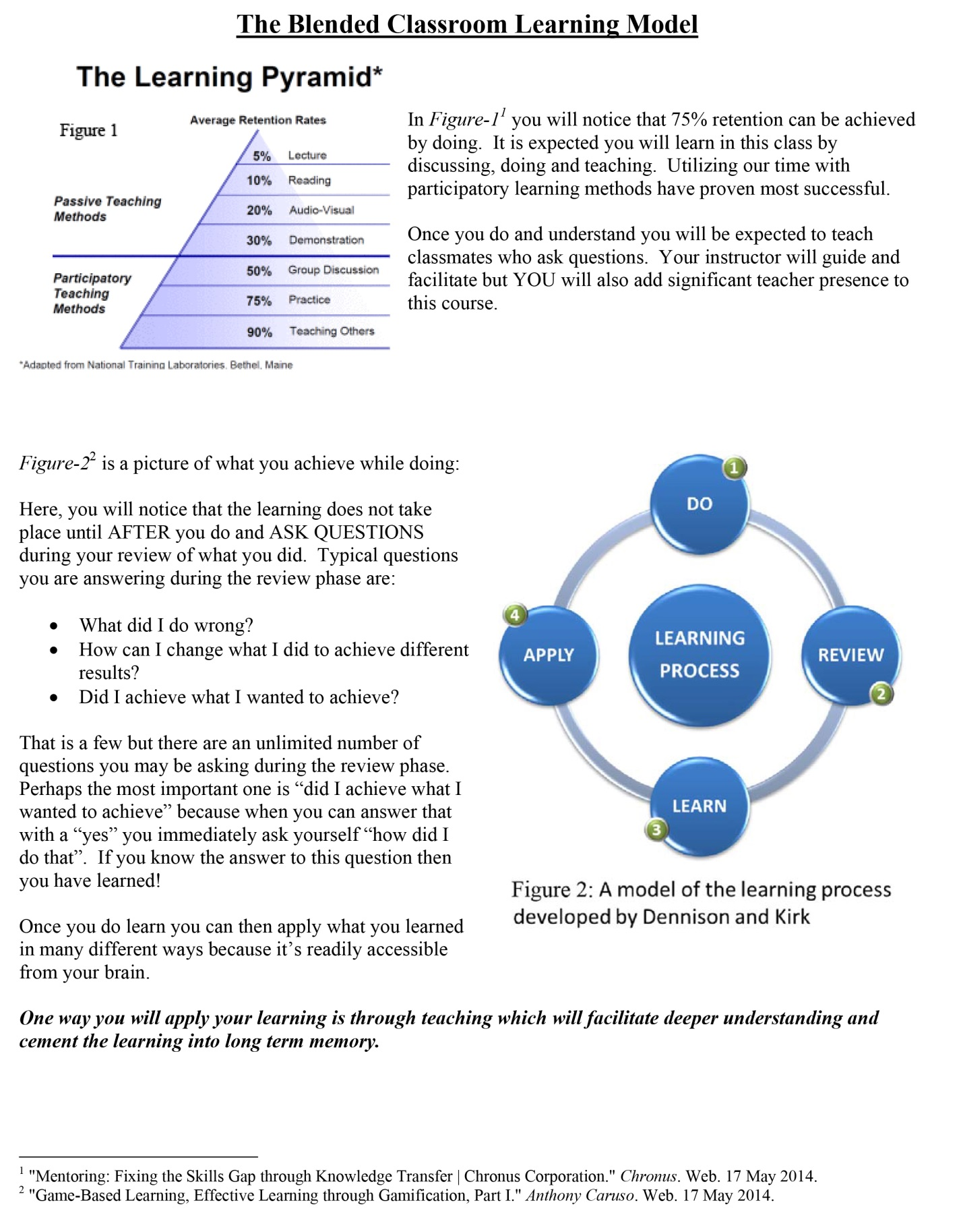

**Course Objectives:**

* Provide students with the sufficient broad-based knowledge to be successful in post-secondary education in the field of information systems.
* Prepare students with the necessary skill sets for an entry-level computer related occupation.
* Provide students with an in-depth knowledge of a variety of software used in IT environments.
* Provide students with the understanding of the various opportunities of employment in networking/computing as well as provide them with the know-how for successful job preparation.
* Impart students with the importance of "soft skills" in the employment arena and require those skills in the classroom setting.
* Provide the opportunity to take nationally recognized certification exams.

**GRADING:**

Your will receive a weekly grade that will be entered into School Tool. Each week counts equally towards a quarterly grade. The four quarters are averaged together with the mid-term and final to achieve a FINAL GRADE in the below fashion:

Q1 * .2 * Q2 * .2 * Q3 * .2 * Q4 * .2 * Mid Term * .1 * Final * .1 = Final Grade

Exams:

Junior Year:

* Mid Term: Initial Website Project
* Final: C#

Other exams during the first year:

* TestOut PC Pro
* HTML
* Precision Century 21 Skills Exam

Senior Year:

* Mid Term: Precision Programming I
* Final: TestOut Network Pro

Projects:

A great deal of the daily work is project based. We complete small projects on a daily basis as I show you how the technology works. We create larger projects to demonstrate how the little skills we work on can be put together in larger programming applications.

Examples of smaller projects:

1. Write a loop that prints out the numbers 1 – 1000 with one number on each line to standard output.
2. Crop out a picture and combine it with another image.
3. Replace a video card in a computer.

Larger projects:

1. Digital Portfolio.
2. Completed Game.
3. Online Arcade
4. Process Management System for Auto Tech.
5. Personal Website

The Digital Portfolio is a culminating project that serves as a record of your success during your time in the program. Inside will be an Arcade. Inside the arcade will be games that you create. Some of the games you will be copying from me as I show you the ins and outs of programming and working in JavaScript. You will create game customizations for each game we create as a group to place the game into your Arcade. You will create a game of your own and place the game into the Arcade.

In addition to highlighting the programming work done the Portfolio also serves as evidence of your completing High School with certain required skills. These required skills will be built during our daily activities and focused during our weekly ELA sessions. You are required to be a positive member of our team and participate in every activity the class engages in. More importantly, you are to do your very best! During the ELA sessions example projects are:

1. Resume
2. Cover Letter
3. Job Application
4. Filmed Practice Interview
5. Filmed Elevator Speech
6. Introductory Video
7. Presentations
8. Career research
9. Grammar
10. References
11. Taking Notes
12. Reading strategies
13. Tax Documentation
14. Business Ethics
15. Product Evaluation
16. Personal Statement

Each of the projects you do with the ELA instructor will be placed in a hard copy portfolio AND your digital portfolio.

**WEEKLY GRADING:**

During each week there are four categories that count towards your grade but one of them is cumulative. Each category listing on your weekly grade report is explained below:

**Classwork:** We keep track of a lot of things we do on a daily basis. Worksheets & short projects. It is something you come in to school and are expected to complete that day.

**Literacy:** There are assignments that count towards your literacy grade on a weekly basis.

**Practicum:** This is where I assess you on how well you perform in a work environment. It is worth 20 points each week. I deduct as many points (up to the whole 20) for whatever I want. Good examples are you didn’t complete an important assignment which is poor workplace productivity – you need tangible things produced for the time you are spending working. Another thing I commonly take away practicum points for is not taking certain assignments seriously. A good example is gratitude’s we write every day. You need to follow the format and put in honest effort. It’s pretty clear when you copy yesterday’s work into today and submit it for credit. That essentially is cheating. I take away your 20 points and notate it along with your practicum grade.

**Assessment:** These are tests and the larger projects.

**Participation:** The total points you achieved divided by the total points available for the week. Notice this is not arbitrary and derived directly from your performance on the other four categories.

**Weekly Score:** All of the other categories averaged together to form one cumulative score for the week that will be entered into School Tool as a reflection of your performance in the course during that period.

**POINT SYSTEM**

There is a weekly point system used in the course. I can add and deduct points with the use of this system. The points are added or deducted from your weekly score. If everyone is doing great I give the whole class points to celebrate. If someone does something special I give them points. I can take points away for not following the classroom rules and expectations.

**DAILY AGENDA**

You are provided with a daily agenda for every class session. Your responsibility is to complete every item on the agenda in the order it is given. If you don’t know what to do it is your responsibility to ask questions. We do a check-in then write a detailed gratitude then do a warm-up that is more lesson specific. We often do a worksheet then go over it as a class. There are small programming assignments every day. We always do a genuine learning reflection on some item we learned about that day. When you have completed your daily work is the time to start working on larger projects that are due later.

If you don’t complete the work for the day during class it is your responsibility to complete the work on your own time. There is no excuse to not complete items on the agenda. The agenda and tools you are provided is your crutch in this course. If you aren’t sure what to do you should be looking back at the agenda and figuring out where you are and what has to be done. When it comes to assignments you should be reading them before you decide you don’t know what to do. It has been my experience the biggest challenge student’s face is they are not looking at the right material providing them the information they need then they are stuck. Follow the 10 steps! Take your time. You can do it!

**PERSONALIZED LEARNING EXTENSIONS**

If all your daily work is done and all your projects are completed you can do a personalized learning extension. At the bottom of each days agenda is a link to the Personalized Learning Worksheet. You can choose to learn more about things of interest to you by filling out the form that asks you to do a little planning about the time you will spend and then reflect on how it went. As with anything feel free to discuss things with me so we can help you get to where you want to be.

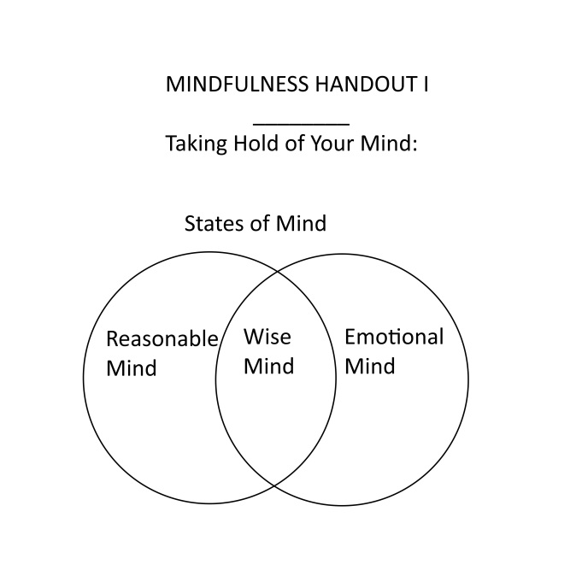**MINDFULLNESS**

There are projects and time spent developing our mindfulness. It is expected you will strive for a wise mind at all times and in all things we do. Your ability to achieve this will determine how you do in the course and your success as a programmer. As with everything we strive for progress not perfection.

RESOURCES

A large part of your success will be determined by your ability to utilize the proper resources. There is a resources section at the top of your grade report where the many resources are assembled. Use them!

QUICK REFERENCE: There is a quick study that highlights a great deal of material from the course. Familiarize yourself and use it!

Daily Work

Every day you do a warm-up, write a gratitude and reflection on the day. Understand what each thing is such that you provide proper answers.

OBJECTIVES: This is the section that tells what we are seeking to learn that day.

Warm-Up: This is an anticipatory question whose intention is to frame the learning sought in the objectives.

Gratitude: Every day you are to write about something you are grateful for. Gratitudes are really great tools to help us stay in the proper frame of mind. I seek to help students better understand how to be more specific about things in the writing through the use of gratitudes as well. Here is an example of less specific and more specific:

Less specific: I am grateful for my grandma she makes every day special.

More specific: I am grateful for my grandma every day she packs me this huge lunch with two sandwich’s and snacks and candy. Yesterday she game me three snicker bars and three puddings plus a big bag of cut up carrots and celery which Jesse, Dave and myself ate at lunch time.

Notice the specific elements. Not just saying ‘snacks’ but showing what snacks.

***The goal for the entire year is to build discipline in being explicitly specific in our thinking and writing.***

Reflection: I want you to provide an authentic reflection to learning that took place for every session we meet. The reflection comes in the form of answering one question from four different categories for a total of 4 questions. There are 10 provided questions in each category so you have choices and can get to know the list throughout the year. The important thing here is you are practicing thinking and writing with specificity. If you provide generic answers and/or your responses do not demonstrate a reasonable amount of thought and effort your reflection will not be approved and you will not receive credit.

Session Approval: Every day there is a session that takes place in which you need to do certain things in order to receive credit:

1. Follow the 10 steps.
2. Complete Warm-Up, Gratitude AND Reflection to acceptable level according to instructions/rubric.
3. Have only a legal/valid excuse to miss timelines. You make up the work right away. I will not go back in time and approve sessions you failed to do the work in a timely fashion. If you are returning from a sickness or extended legal absence you have a maximum of two-days to make up work.

Whether you are in class or not, failing to receive credit for the course sessions will be highly detrimental to your grade on a weekly basis.

If you have all your work done in an acceptable fashion (you have 100% on everything) you can decide what to do provided it is a learning activity!

At the end of each week if your weekly score fails to achieve 65% or better I will communicate with your parent you did not get the job done that week. They build up.

USING THE BATHROOM: There is an item designated as the bathroom pass. In order to use the bathroom the pass must be there.